**Phase B - Fabrication, Assembly and Alignment of ME Mark II Target**

Michael McGee, James Wilson and Michael Stiemann

May 12, 2014

**Introduction:** The target procurement cycle begins each fiscal year when funds become available. Under this current cycle, two target assemblies are needed and the quantities provided within consider them. Also, extra parts are sometimes considered to offset the possible consumption or damaging of parts during the fabrication process. All parts or components procured through an outside Vendor shall be provided with a Written Inspection Report and Material Certifications.

1. Order Target components under Package 2-10

* Package 2 - Target Casing Components (longest lead-time items)
  + Fabricate (a quantity of (6)) for MB-433758 - Water Inlet Tube
  + Fabricate (a quantity of (3)) for ME-433920 Rev. B - Inner Tube
  + Fabricate (a quantity of (3)) for ME-433921 Rev. None - Outer Casing
  + Fabricate (a quantity of (6)) for MC-433922 Rev. None - Inner Tube Dam
  + Fabricate (a quantity of (3)) for MB-433924 Rev. A - Casing Rail Mount
  + Fabricate (a quantity of (3)) for MB-433946 Rev. A - Casing Rail Mount DS
* Package 3 – External target components
  + Fabricate (a quantity of (2)) for MD-433793 Rev. A – Upstream End Wall
    - Order 12” OD (304.8 mm) 316L SS Conflat non-rotatable blank flange from NorCal (a quantity of (2))
  + Fabricate (a quantity of (4)) for MB-433937 Rev. A – Water Flange
  + Fabricate (a quantity of (2)) for MB-433797 Rev. None – Helium Inlet Tube
  + Fabricate (a quantity of (10)) for MB-433910 Rev. None – Tooling Ball
* Package 4 – Internal target components
  + Fabricate (a quantity of (26)) for MC-433743 Rev. A – Target Fin Pressing Plate
  + Fabricate (a quantity of (3)) for MB-433771 Rev. B – Cooling Rail Support Bracket DS
  + Fabricate (a quantity of (3)) for MB-433772 Rev. B – Rail Support Bracket US Locking
  + Fabricate (a quantity of (3)) for MB-433773 Rev. B – Rail Support Bracket US Sliding
  + Fabricate (a quantity of (3)) for MC-433785 Rev. B – Rail Support Base Plate DS
  + Fabricate (a quantity of (3)) for MC-433786 Rev. B – Rail Support Base Plate US
  + Fabricate (a quantity of (3)) for MB-433905 Rev. None – Cooling Rail Bracket Downstream
  + Fabricate (a quantity of (3)) for MB-433906 Rev. None – Cooling Rail Bracket Upstream
  + Fabricate (a quantity of (3)) for MD-433913 Rev. A – Horizontal Budal Fin Bracket
  + Fabricate (a quantity of (3)) for MD-433917 Rev. A – Vertical Budal Fin Bracket
* Package 6 - Internal target components
  + Fabricate (a quantity of (60)) for MB-433798 Rev. A – Spring Centering Washer
  + Fabricate (a quantity of (6)) for MB-433799 Rev. A – Budal Spring Centering Washer
  + Fabricate (a quantity of (10)) for MB-433865 Rev. None – M10 Aluminum Vented Screw
  + Fabricate (a quantity of (10)) for MB-433911 Rev. None – 8mm Dia x 10mm Lg Shoulder Screw
  + Fabricate (a quantity of (10)) for MB-433912 Rev. None – Budal Connection Rod
  + Fabricate (a quantity of (10)) for MB-433927Rev. None – M2 Flat Washer
  + Fabricate (a quantity of (10)) for MB-433928 Rev. None – M2 Jam Nut
* Package 7 - Internal target components
  + Fabricate (a quantity of (6)) for MB-433747 Rev. None – Budal Fin Pressing Plate
  + Fabricate (a quantity of (8)) for MB-433774 Rev. A – Cooling Rail Support Rod
  + Fabricate (a quantity of (14)) for MB-433776 Rev. B – M10 Spherical Washer Bottom
  + Fabricate (a quantity of (14)) for MB-433777 Rev. A – M10 Spherical Washer Top
* Package 8 – Hardware
* Package 9 - DS window (Endwall) assembly
  + Procure (3) DS Target Windows (Endwall): MC-433909 Rev. None – Downstream Endwall, PF-60 electron beam welded 1.25 mm thick beryllium window to 12” 6061 AL CF Flange over a 120 mm aperture per Materion dwg. No. 67892 (contact Materion at [Jose.Villanueva@materion.com](mailto:Jose.Villanueva@materion.com))
* Package 10 – US Endwall and Window
  + Procure (3) US Target Windows: MB-363049 Rev. None – Braze Assembly, 0.010” thick, f1.0” PF-60 Beryllium window with a ) 2-3/4” SS CF flange (contact: Omley Industries, [dave@omley.com](mailto:dave@omley.com))
  + Procure (2) US Target Endwall Flanges: MD-433793 Rev. A – Upstream End Wall, NorCal 12” O.D. (304.8 mm) Non-rotatable SS CF flange from Midwest Vacuum (contact: (630) 323-5399)
* Procurement of special parts
  + Procure (3) Budal feedthru with CF flange; ISI special (ref. Quote 14760) SPCL Multi 5-pin F/T on 2.73” 316L CF flange (MDC Vacuum Products Inc. contact [sdix@vacuumone.com](mailto:sdix@vacuumone.com))
  + Procure CF seals: (10) 12” CF (NorCal) CeFIX 1100 series AL gaskets P/N G-1200-I-AL and (6) 2-3/4” (275) CF Copper gaskets, P/N G-275 from Midwest Vacuum (contact: (630) 323-5399)

1. Package 1 - Target Cooling Rail Fabrication (longest fabrication time items)

* Procure and machine primitive cooling rail aluminum stock
  + Purchase (8) Extruded aluminum bar stock 2” thick x 5” wide x 55” length, SAP 6061-T651H 214207 ASTM 8221 Accu-u-Bar+ (provided by Metal Supermarkets; contact (815) 282-6544) and deliver to 38 Shabonna (Cut Shop)
  + Clean up ends at VMS
  + Contact Crystal Precision Drilling Inc. ((815) 633-5460) for gun drilling and transport
  + Crystal Precision Drilling Inc. to fabricate (8) pieces per MD-433898 – Rev. None – Cooling Rail: set up and drill (2) 9.0 mm diameter holes by 1337 mm deep
  + Vendor shall ultrasonically inspect hole locations (at three positions; A, B and C defined in Figure 1)
  + Vendor shall assign serial numbers (S/N) 1-8 to aluminum stock pieces and complete template (provided by FNAL) shown in Figure 1

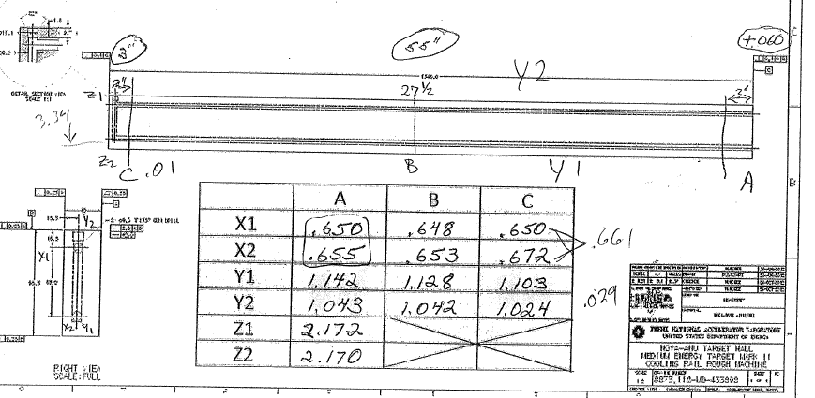

Figure 1: Measurement template for Vendor ultrasonic inspection location.

* Document and evaluate gun-drilled hole variations using spreadsheet template and choose the (4) stock pieces with the least deviation (given that these are within the tolerances established by MD-433898 – Rev. None – Cooling Rail Rough Machine)
* As a machining reference, relocate datum at center (from US end) and machine the (4) stock pieces to the dimensions provided in drawing MD-433898 – Rev. None – Cooling Rail Rough Machine (define hole #1 (upper) and #2 (lower) while viewing from the US end)



1

2

(mm)

Figure 2: Target cooling rail end view (from MD-433898) used for gun-drilling.

* Accurately measure the longitudinal distance (depth) of each gun-drilled hole to determine the location (or placement) of the return line hole using a depth gauge with extensions
* Estimate the vertical return hole location based on depth gauge measurement by using the depth averaged measurement value between holes #1 and #2 taken from the US face and subtracting it from the total length of the stock piece
* This value plus the hole radius 4.5 mm defines the longitudinal (z) distance to the hole center from the DS face
* Using the front side as a reference, average the center line position in the plan view (x) between holes #1 and #2 at the DS end (this will give the transverse location for the 9 mm drill bit)
* Finally, the depth of the hole shall be based on the bottom hole’s distance from the top face (drill deep enough to break through the lower hole #2 and continue down with the bit until tip breaks the bottom perpendicular hole’s wall as shown in Figure 2)

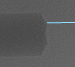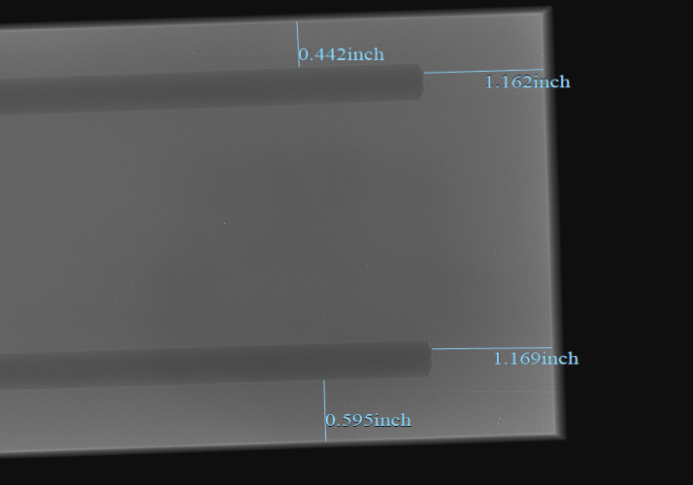

Figure 3(a): Close-up of hole. 3(b) X-ray example of a stock piece showing hole-pattern.

* Machine weld-prep per MD-433898, Rev. None – Cooling Rail Rough Machine

1. Provide the following parts and equipment

* Provide (2) plug weld samples and (12) plugs per MB-433899, Rev. None using the same material: Extruded aluminum bar stock 2” thick x 5” wide x 55” length, SAP 6061-T651H 214207 ASTM 8221 Accu-u-Bar+ (note that extra stock is available and stored at MI-8 for this purpose)
* The plug weld sample design is shown in Figure 4 (which has the same weld-prep parameters as MD-433897)
* Provide (6) aluminum ER 4043 welding rods
* Provide any purple nitrile gloves, face shield and safety glasses needed

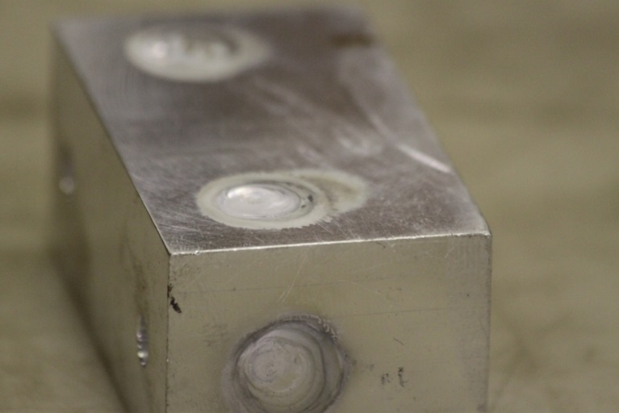 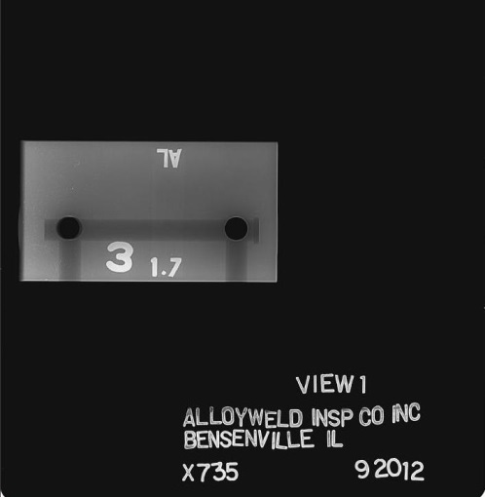

Figure 4(a): Side-view of plug weld sample. 4(b) X-ray of weld sample.

* Prep (a quantity of (4)) aluminum stock pieces for welding per MD-433901
  + Clean aluminum stock pieces (by standing upward with socket end immersed in solution, weld samples and ER 4043 AL rod at Alloyweld
  + By following cleaning procedure
  + Degrease using Trichloroethylene (TCE) a vapor solvent for organic materials
  + Alkaline bath w/ pH 11-11.5 (for 5 min)
  + Tap Water Rinse (ambient) to remove residual alkaline solution (for 5 min)
  + Nitric Acid Etch 38-48% Nitric, 0.7-0.9% HF-3 (for 2.5 min)
  + DI water Rinse (for 5 min) at ~ 90 F
  + Oven dry at 130 F (for 30 min)
* Handle cleaned components with purple nitrile gloves following this process to prevent contamination
* Setup the Nitric Acid bath such that only the plug weld-preps are exposed to the etching
* Welding by Alloyweld (round the pure tungsten rod tip)
* Weld Parameters (from past experience and dependent on Welder’s preference)
  + AC TIG (HF Impulse) Welding
  + Plug Weld Parameters
    - Positive electro +170/ Neg. electro -180, balance 80% & 130 Hz frequency
    - Tungsten cup #5, flow 25 – 30 scfm (75% He/25% Ar) gas purge
* First, complete the plug weld samples using parameters shown above
* X-ray inspect the plug weld samples (as shown in Figure 5(b)) after welding and then certify

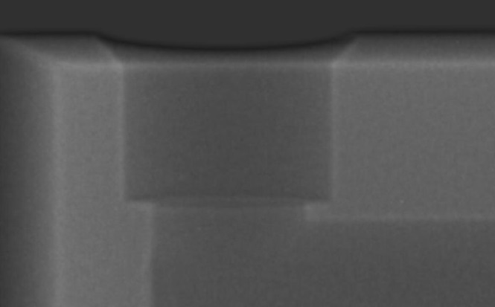 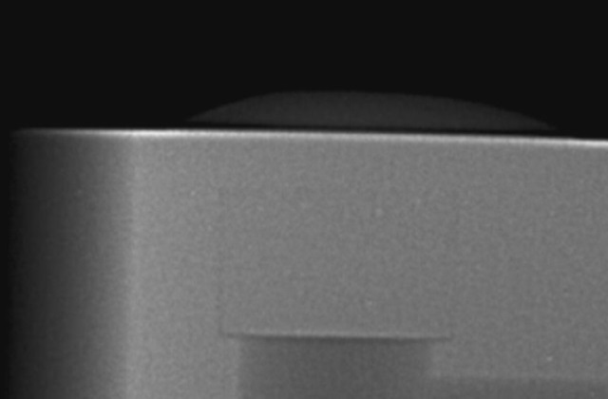

Figure 5(a): Side-view of weld-prep X-ray. 5(b) After welding.

* Radiograph interpretation/certification provided by Alloyweld
* Then, if plug weld meet at least NAS-1514, Class 2 proceed to weld the actual cooling rail construction stock pieces
* If not, contact the Target Engineer for consultation
* Considering that the plug weld samples met NAS-1514, Class 2 and the cooling rail plugs were welded, complete a set of X-rays
* Return to FNAL and provide the X-ray results to the Target Engineer

Target Group Member(s) Date

1. Final machining of cooling rails

* Deliver (4) plug-welded aluminum stock pieces with serial numbers still in-tact to VMS
* Preserve serial numbers on each piece by stamping in an appropriate place on either US or DS end face (see Figure 6(a))
* Machine per MD-433896, Rev. A – Cooling Rail Final Machine (as shown in Figures 6(a) and 6(b))

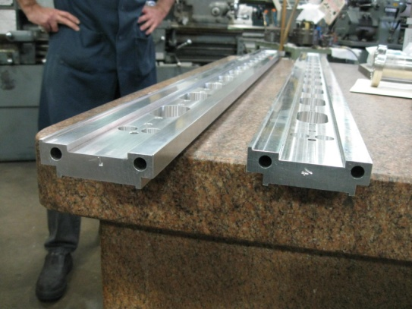 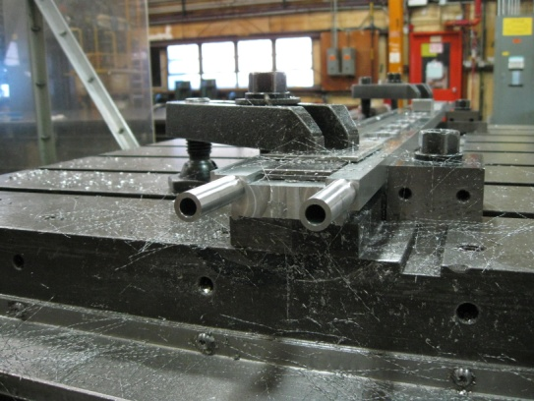

Figure 6(a). Example of target cooling rail during final machining. 6(b). Target cooling rail completed.

1. Final Weldments for Cooing Rails

* Provide the following parts and equipment
* Procure (10) Mini flex SS-439-120-1000 bellows
* Procure (10) 1” friction-welded AL (1050) - SS (304) blanks, P/N FWJ00001 (contact: Scientific Products Ltd in UK, [enquiries@asscientific.co.uk](mailto:enquiries@asscientific.co.uk))
* Machine necessary parts at VMS (FNAL)
  + Machine (a quantity of (10)) parts MB-433902 Rev. None (Transition Bushing) and (a quantity of (10)) MB-433903 Rev. None (Endwall Water Connection) and fit-up bellows (Mini-flex SS-439-120-1000)
  + Fabricate (2) Socket weld samples per Figure 7 at VMS

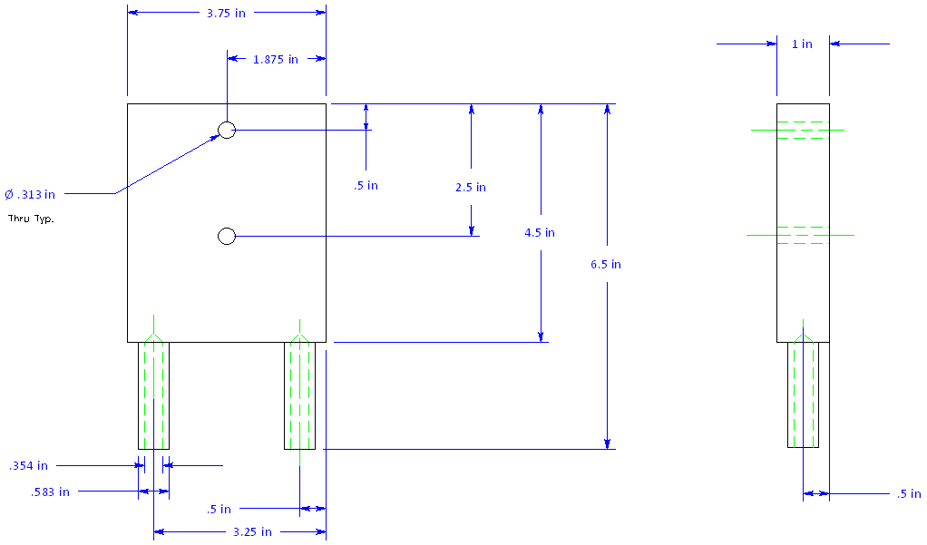

Figure 7. Socket-weld sample geometry and dimensions.

* Provide (1) Argon purge bottle, regulator and connecting tube needed for micro-TIG welding
* Provide yellow cooling rail holding fixture
* Provide (12) aluminum ER 4043 welding rod
* Provide transport container or a way to protect each rail
* Target cooling tube constraints (fixtures) to hold bellows after welding
* Provide (2) aluminum socket-weld samples for initial testing at Alloyweld using similar dimension and material as in the design
* Also, provide (2) SS tube samples for weld evaluation
* Provide any purple nitrile gloves, face shield and safety glasses needed
* Schedule back-to-back appointments at Ability Welding to complete SS welds (SS-AL transition and bellows) and then at Alloyweld Inc. for aluminum socket joint to cooling rail connection
* Note that (2) Transition Brushings and Endwall Water Connections will be used for weld samples in conjunction with the weld sample blocks shown in Figure 8
* First, practice micro-TIG on (2) small SS tube samples provided in butt-weld joint form
* Then, weld all (6) SS assemblies at Ability Welding and following the visual inspection, the less acceptable welded pieces are to be earmarked used as the (2) spare weld samples

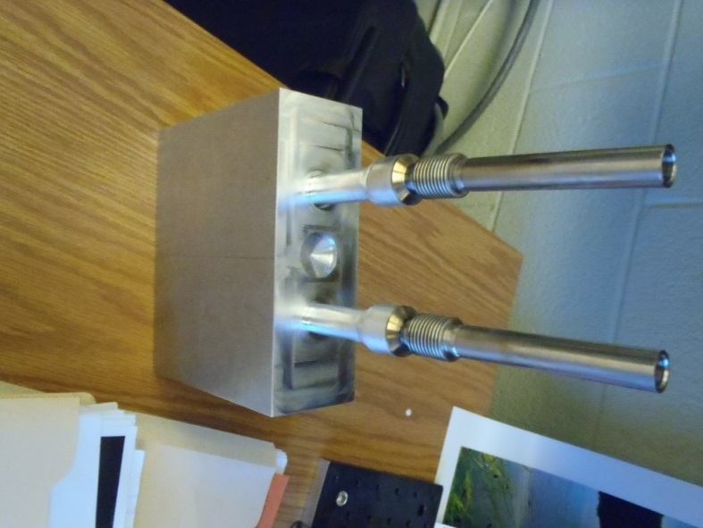

Figure 8. Socket-weld sample completed.

* Transport assemblies to Alloyweld
* Prepare (6) sets for welding per MD-433901, Rev. A – Cooling Rail Weldment
  + Clean cooling rails (by standing upward with socket end immersed in solution as shown in Figure 9(a)), SS-AL sub-assemblies (see Figure 9(b), note that SS components will pickle in Nitric Acid Etch bath so only immerse the aluminum), socket weld samples and ER 4043 AL rod at Alloyweld
* By following cleaning procedure
  + Degrease using Trichloroethylene (TCE) a vapor solvent for organic materials
  + Alkaline bath w/ pH 11-11.5 (for 5 min)
  + Tap Water Rinse (ambient) to remove residual alkaline solution (for 5 min)
  + Nitric Acid Etch 38-48% Nitric, 0.7-0.9% HF-3 (for 2.5 min)
  + DI water Rinse (for 5 min) at ~ 90 F
  + Oven dry at 130 F (for 30 min)
* Handle cleaned components with gloves following this process to prevent contamination
* Also, limit the amount of Nitric Acid fluid within the target cooling rail
* Setup the Nitric Acid bath such that only the socket tube weld preps are exposed to the etching

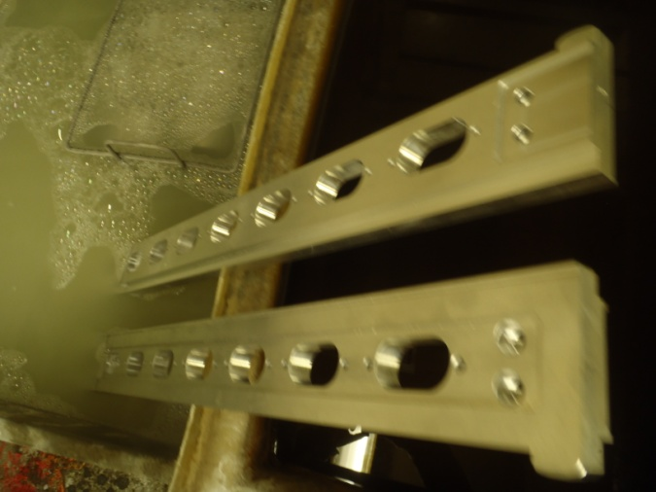 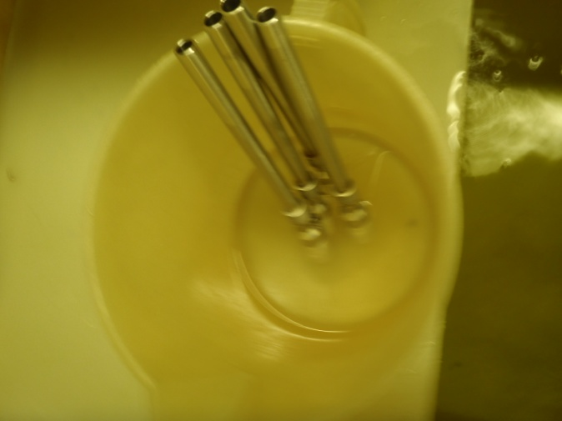

Figure 9(a). Target cooling rail immersion. 9(b). Transition SS-AL sub-assembly immersion (AL end only).

* Welding by Alloyweld (round the pure tungsten rod tip)
* Weld Parameters (from past experience and dependent on Welder’s preference)
  + AC TIG (HF Impulse) Welding
  + Socket Weld Parameters
    - Positive electro +100/ Neg. electro -120, balance 80% & 130 Hz frequency
    - Tungsten cup #5, flow 25 – 30 scfm (75% He/25% Ar) gas purge
* First, weld socket-weld samples using parameters shown above and yellow cooling rail holding fixture
* X-ray inspect the socket-weld samples (as shown in Figures 10(a) and 10(b)) after welding and then certify
* Use yellow cooling rail holding fixture to keep each target cooling rail upright during welding (i.e. inverting the socket joint for good access)
* Continue onto the actual (4) cooling rail assemblies and complete aluminum socket welds
* Complete X-ray inspection of target cooling rails (as shown in Figures 10(a) and 10(b))

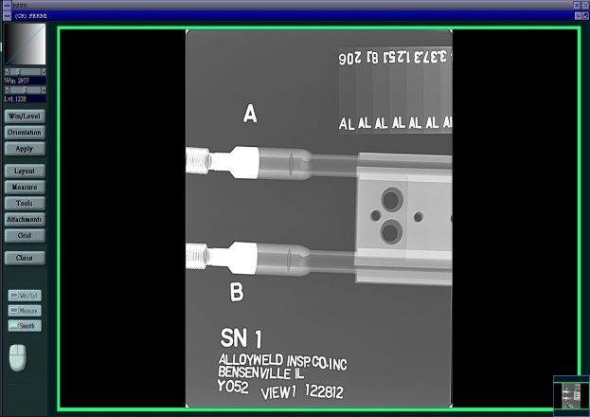 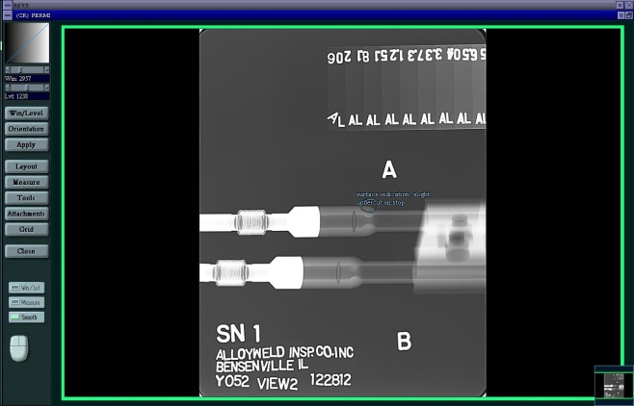

Figure 10(a). X-ray example for S/N (view 1). 10(b). X-ray example of view 2.

* Transport target cooling rails back to FNAL using transport crate as shown in Figure 11

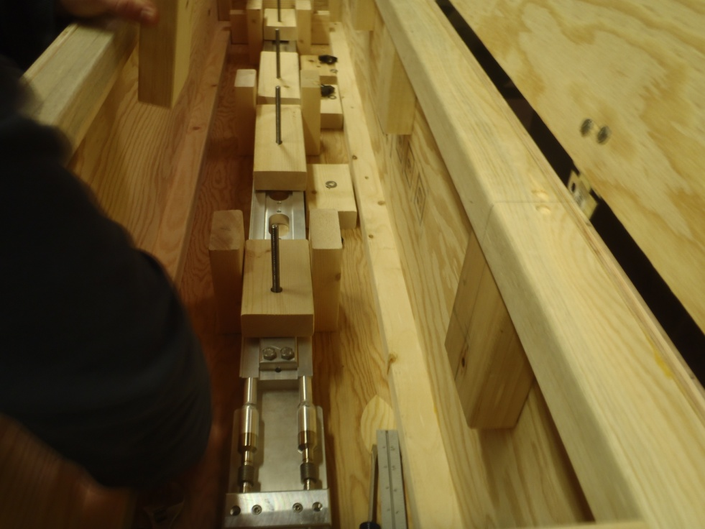

Figure 11. Careful transport of target cooling rails using crate provided (in stacked configuration).

* Leak check of completed assembly shall be performed using a helium (He) mass spectrometer (no detectable leak at a sensitivity of 1e-9 atm-cc/sec or equivalent) per ES-296471-1 as shown in Figures 12(a) and 12(b)

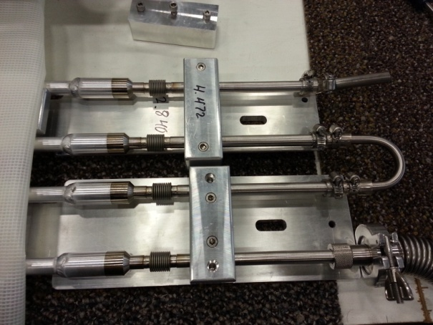 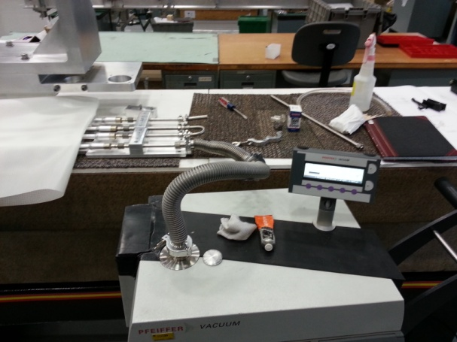

Figure 12(a). Example of leak checking setup. 12(b). Target cooling rails certified leak tight.

* A pressure test followed (200 psig for 2 hours) also per ES-296471-1 (see Example of pressure test attached)

Target Group Member(s) Date

* Document leak check and pressure test and provide written or scanned results to Target Engineer
* Store certified target cooling rails in transport crate (shown in Figure 11) until needed

1. Assembly of Target Casing (drawing ME-433923 – Machined Casing)

* Receive and inspect machined parts from Vendor
  + Remove parts from crating
  + Hand-wipe down parts using alcohol
  + Inspect machined parts and compare critical dimension and tolerances to drawings and written inspection report provided by Vendor
  + Note any deviations from drawing and inform Supervisor, Procurement Specialist or Target Engineer
* All welding is completed at FNAL by the same person for consistency
* Weld samples are used to validate the process throughout, however the actual welds are not to be X-ray inspected (due to complex geometry and X-ray machine limitations)
* Weld Inner Tube Dams (US & DS) into place per ME-433919 Rev. A
* Develop weld samples; “flat” geometry for target inner tube to outer casing and tube geometry weldment per ME-433923 (Casing Machined) as shown in Figures 13(a) and 13(b), respectively

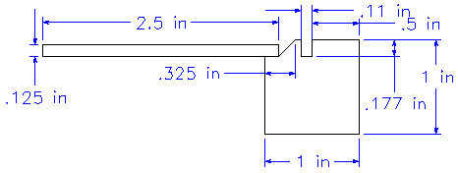 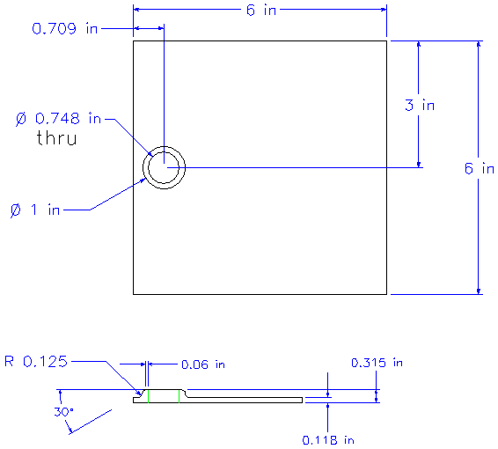

Figure 13(a). Target casing weld sample geometry (12” in length). 13(b) Inlet/out tube weld sample.

* Weld samples using the following parameters
  + Degrease and acid etch ER-4043 AL rod (providing enough for all welds; samples, target casing and tubes) at Alloyweld and contain within desiccant (vacuum/inert) canister either under vacuum or at a positive pressure in an Argon atmosphere
    - Degrease using Trichloroethylene (TCE) a vapor solvent for organic materials
    - Alkaline bath w/ pH 11-11.5 (for 5 min)
    - Tap Water Rinse (ambient) to remove residual alkaline solution (for 5 min)
    - Nitric Acid Etch 38-48% Nitric, 0.7-0.9% HF-3 (for 2.5 min)
    - DI water Rinse (for 5 min) at ~ 90 F
    - Oven dry at 130 F (for 30 min)
* Handle cleaned components with gloves following this process to prevent contamination
* Welding by FNAL (Welder)
  + Weld (2) “flat” or plate target casing samples
  + Weld (2) Inlet/out tube weld samples
  + Clean parts with alcohol using gloves and scrap weld prep surfaces with clean blades Welding machine set for AC (120 Hz), 200 A Max at 80% Balance
  + Average current used ~180 A
  + Use 3/32”, 2% Thorirated Ti rod with tip ground to a point
  + Apply Tungsten cup #5, flow 25 – 30 scfm (75% He/25% Ar) gas purge
  + Apply full-penetration to welds
* Figures 14(a) and 14(b) provide a post-welding view of the flat target casing geometry weld sample and inlet/outlet tube, respectively (Note: remove extra material around inlet/outlet weld sample (~ 1-1/2” diameter) and provide flat for support during X-ray as shown in Figure X(b))

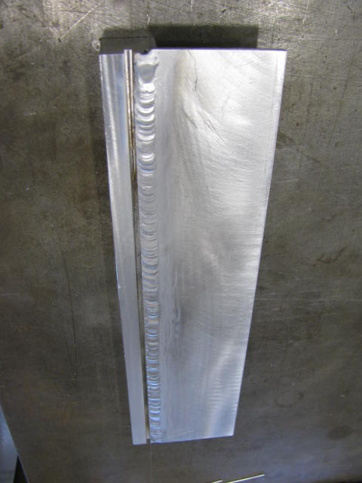 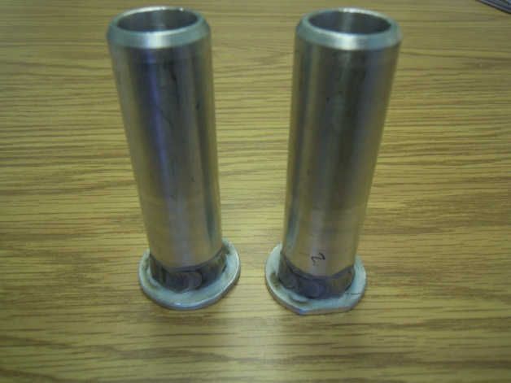

Figure 14(a). Flat target casing geometry for weld sample. 14(b). Inlet/outlet tube weld samples.

* X-ray Inspection at Alloyweld
  + X-ray inspection of target casing aluminum weld samples to be completed at Alloyweld per NAS 1514, Class 1 as shown in examples from Figures 15(a) and 5(b)
  + Sample welds must meet at least Class 2 with full penetration

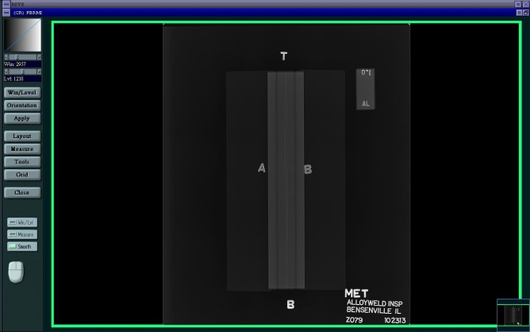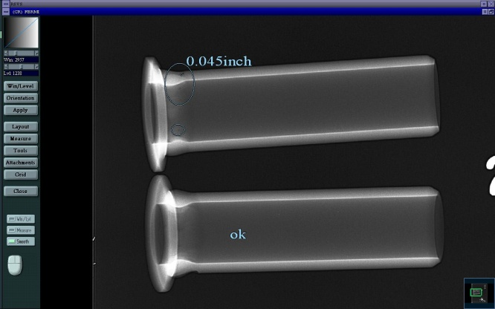

Figure 15(a). Flat target casing geometry weld sample X-ray. 15(b). Inlet/outlet tube weld sample X-ray.

* Finally, weld sample certification is based on full-penetration of the weld samples (Examples of the two weld sample geometries are given in Figures 16(a) and 16(b))

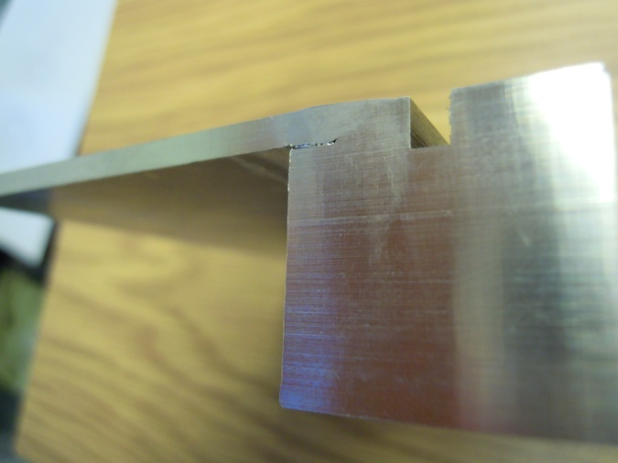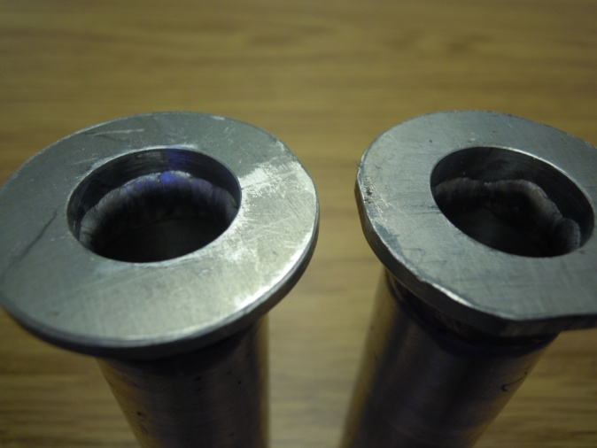

Figure 16(a). Flat target casing geometry weld sample penetration. 16(b). Inlet/outlet tube weld samples.

* Clean (or scrape) Inner Tube (ME-433920) and Outer Casing (MC-433921) along circumferential area where fillet will be applied at each end US and DS per Casing Weldment (ME-433919)
* The weld certification process leads to assembly of the target casing through the insertion of the Inner Tube into the Outer Casing per ME-433919 – Casing Weldment as shown in Figure 17(a).
  + First clean parts with alcohol using gloves and scrap weld prep surfaces with clean blades (This cleaning is effective for 4 hours after scraping)
    - Clean (or scrape) Inner Tube Dams (MB-433922) and Inner Tube (ME-433920) at US and DS locations indicated on Casing Weldment (ME-433919, Section Detail View)
  + Inner tube and outer casing fit-up
  + An ACME screw with alignment fixturing is used to carefully guide the inner tube while the outer casing remains clamped
  + Maintain proper orientation of machined parts during assembly
  + Note orientation of US/DS shown in drawing ME-433921, Section B-B
  + When viewing the DS end, looking towards the US, holes for the cooling water tube attachment (inlet and outlet) must be 110 degrees (or at 11 o’clock) US and -110 degrees (or at 7 o’clock) on the DS end
  + Hold inner tube from inside using a mandrel or chuck
  + Carefully, slide (manually) the inner tube along the length of the outer casing inserting it while maintaining the relative final position of the inner tube to the outer casing (Note that it is important to minimize rotation of one part relative to the other following the insertion)
  + Confirm that there is enough clearance to fully insert the inner tube into the outer casing
  + Truing rings are used to correct any out-of-round location regarding the outer casing during the process as shown in Figure 17(b).

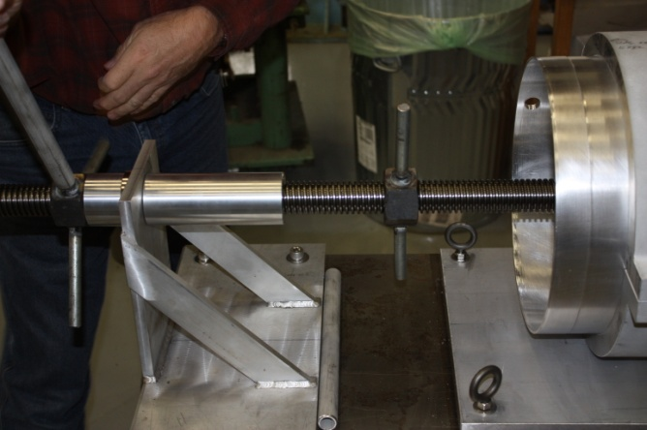 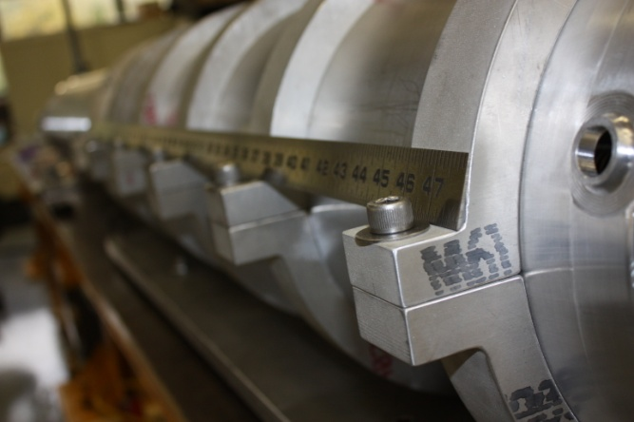

Figure 17(a). AMCE screw and fixturing for inner tube insertion. 17(b). Truing rings for correction.

* A plastic leader is also provided on the leading edge of insertion and attached to the DS inner tube as shown in Figure 18(a)
* Use the hydraulic ramp system provided for general insertion over most of the length
* Due to the location of the positive-stop weld prep design, insertion of the inner tube begins at the US end of the outer casing and moves towards the DS end
* The inlet and outlet tube locations relative to the inner helical screw water channel path are pre-aligned before beginning the insertion
* The difference is split between optimal position for each tube location relative to the dam placement on the helical screw
* Figure 18(b) shows an example of a mismatch between the radial position of the tube and internal helical dam
* A large strap wrench will be available during insertion to compensate for unwanted rotation of the inner tube relative to the fixed outer casing upon insertion
* Always use the strap wrench while also moving the inner tube longitudinally

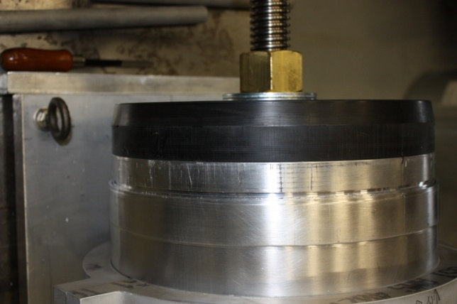 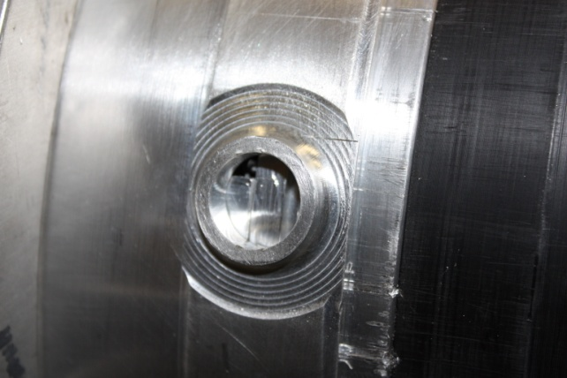

Figure 18(a). Plastic leader for inner tube insertion. 18(b). Example of dam mismatch to tube hole.

* Once the insertion is complete (outer casing is against positive-stop weld prep DS) and there is a proper alignment between inlet/outlet holes and internal dams, then breakdown the ACME/hydraulic insertion setup
* Weld assembly per Casing Weldment (ME-433919)
* Position target casing onto roller-support system needed for welding
  + Clean weld areas again with alcohol using gloves
  + Welding machine set for AC (120 Hz), 200 A Max at 80% Balance
  + Average current used ~180 A
  + Use 3/32”, 2% Thorirated Ti rod with tip ground to a point
  + Apply Tungsten cup #5, flow 25 – 30 scfm (75% He/25% Ar) gas purge
* Apply full-penetration to welds as shown in Figure 19
* Switch Ar purge line from DS hole for cooling tube to US end (Restrict flow using aluminum foil at the DS hole for cooling)

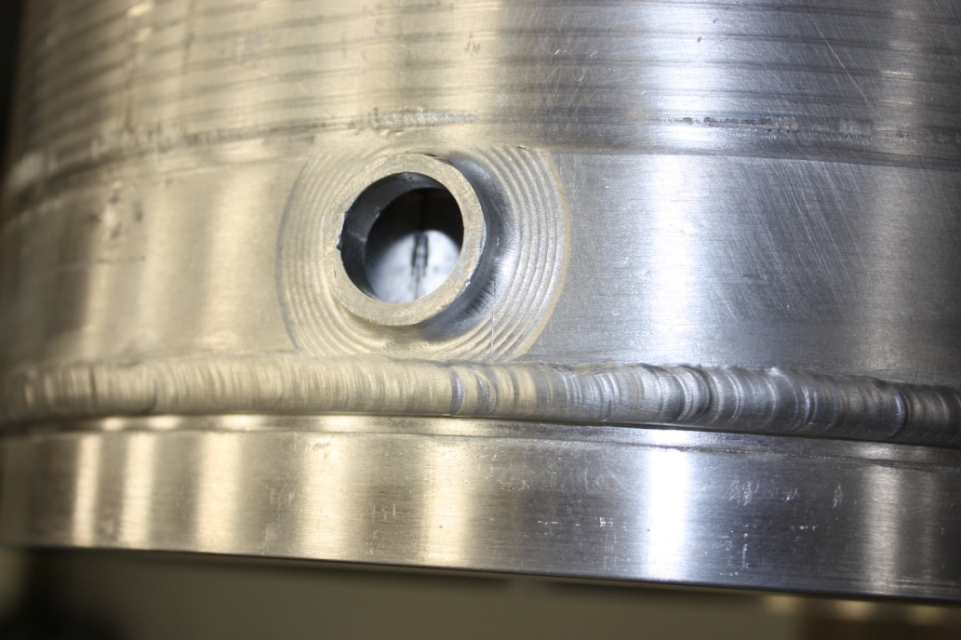

Figure 19. Example of US target casing weldment.

* Send target casing and aluminum inlet/outlet tubes to VMS for weld-prep
* Follow weld preps shown in Figures 20(a) and 20(b)

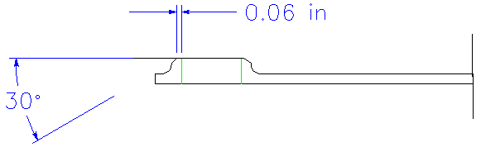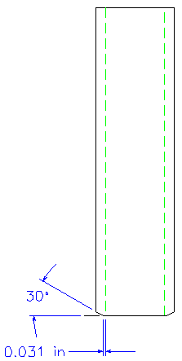

Figure 20(a). Example of weld prep for target casing holes. 20(b). Weld prep for inlet/outlet tubes.

* Weld Parameters
  + AC TIG (HF Impulse) Welding
  + Weld “flat” or plate target casing samples
  + Clean parts with alcohol using gloves and scrap weld prep surfaces with clean blades
  + Use etched ER-4043 AL rod (processed by Alloyweld) with 75% He/25% Ar mixture at the weld cup (set flow for 20 cfm at top of ball)
  + Handle ER-4043 AL rod using gloves
  + Welding machine set for AC (120 Hz), 200 A Max at 80% Balance. Average current used ~180 A
  + Use 3/32”, 2% Thorirated Ti rod with tip ground to a point
  + Apply full-penetration to welds
* Complete X-ray inspection at Alloyweld per NAS-1514, Class 1 Standard
  + Sample welds must meet at least Class 2 with full penetration.
  + If samples are acceptable, then weld the target casing outer tube onto the inner pipe per ME-433919 Rev. None using the same welding parameters given in step #2
* Continue fabrication using ME-433923 Rev. C by following Note steps 1 through 6 (denoted as a through f) in order (summarized below)
  + Create (2) inlet/outlet tube weld samples by following steps 2a through 2d
  + Again, follow step #3 regarding X-ray certification
  + Follow step #4 regarding inlet/outlet tubing welding to target casing
  + All welds to be leak tested as required by MSD Engineering Specification 1320.000-ES-296471 Rev. 1 (see attached spec)

Target Group Member(s) Date

* + After welding mask inlet and outlet tubes over the 100 mm length and each end (avoid masking tube welds) then hard coat anodize type III Class 1 to 0.025 mm – 0.05 mm total layer thickness followed by mid-temp nickel acetate seal over unmasked surfaces
  + Verify item 2 radius to the ID of Casing Weldment
  + After alignment drill, pin and fasten using (2) socket head screws in place
  + M8 tapped holes to be drilled and tapped into pre-cut casing
  + Overall length (1477.5 mm) to be achieved by facing or removing a nominal 2 mm from each end
  + Machine knife edges

1. Package 5 - Procurement, Fabrication and Certification of Target Graphite Fins

* Procure graphite fins through Vendor POCO Inc. ([Cindy_Hamilton@Entegris.com](mailto:Cindy_Hamilton@Entegris.com))
  + Procure (32) pieces of ZXF-Q51 graphite plate, 7.4 mm x 115 mm x 151 mm (all surfaces ground flat to within +0.127 mm/-0.000 mm)
  + Note that the last digit “1” within the material definition designates it as a purified material (where the total impurities are reduced to 5 ppm or less)
  + Weigh and measure dimensions of stock graphite material upon arrival
  + Inventory and document weight, volume and estimate graphite density
* Machining of Target Fins
  + Machine fins at VMS by fabricating each section of (4) fins from one piece of stock (e.g. sample 1 is MC-433742, Rev. A, sample 2 and 3 are both MC-433728, Rev. A and sample 4 is MC-433729, Rev. A) and adding this information to the inventory spreadsheet
  + Also use (2) pieces of the (32) to machine (a quantity of (2)) MB-433915, Rev. A and (a quantity of (2)) MC-433918, Rev. A
  + Measurement thickness and flatness of individual fins (at 6 points) using Coordinate Measurement Machine (CMM)
  + Evaluate relative thickness and flatness given a pressing plate section of fins using the spreadsheet template
  + Define placement of target graphite fins within cooling rail and bake-out fixture

1. Bake out of graphite fins

* Note that complete target fin assemblies are provided in pairs based on the production of two targets per fiscal year
* Prepare for bake-out
  + Prepare for bake-out Initial RGA scan of bake-out vacuum chamber and stainless steel (SS) fixture
  + Clean fins within class 1000 cleanroom
    - Use Lab Grade (Isopropyl) Alcohol to wipe down and allow to dry
    - Place the fins inside a SS beaker which is surrounded by a slighting larger bath of DI water
    - Ultrasonically clean in DI water for 30 seconds
    - Remove any residue with another Alcohol wipe down
  + Load graphite fins into SS fixture and secure within the bake-out vacuum chamber
    - Place the fixture of the lowest number target (MET-XX) at the blank CF flanged end for easier access following the bake
  + Attach CF flange to open end(s) and pump-down system
  + Perform an initial RGA scan and document
  + Insert into oven
* Bake-out
  + Start bake ramping to 300 degrees C (only 120 degrees C if RGA scan determines low amount of hydrocarbons) and monitor pressure
  + Initially, run rougher pump to handle water load until presence of water is reduced (vacuum readout goes down to 1 E-3 Torr)
  + Continue bake for at least 2 days in order to drive the water vapor out
  + Terminate bake and allow oven to cool below 50 degrees C (~ 1 day)
  + Perform RGA scan and document
  + Wait until Target Technician is ready for the target fins (target casing is available)
  + Remove blank CF flange and then, lowest number target (MET-XX) fins
  + Blow down fins using dry nitrogen
  + Package graphite fins for target next in the sequence into air-tight bags, back-filling with dry N2 gas
    - The graphite fins for the other target should remain within the vacuum chamber
* Reseal the vacuum chamber, pump-down and leave under vacuum using a turbo at MI-8

Target Group Member(s) Date

1. Target Casing Final Assembly

* Machine Target Casing
  + Finish target mounting drilling fixture needed for target casing
  + Final machining of target casing (blind holes and knife edges) at VMS
  + Target casing final machining completed
  + Carefully, drill US and DS holes for mounting of cooling rail within target casing
* Prepare for assembly of target
  + Use purple nitrile gloves during the entire process
  + Always bag graphite target fin assembly when finished with a task or procedure for that day
* Assemble target fins with cooling rail
* Attach US and DS tooling balls onto target casing for the target
* Align target fins
  + Contact AMD (submit an Alignment Work Request)
  + Alignment set up using laser tracker system
* Insert cooling rail and fins into target casing for target
* Attach to mounts and secure

Target Group Member(s) Date

* AMD Referencing
  + Perform referencing of internal target fins (US and DS) to external tooling balls using laser tracker system

AMD Crew Member(s) Date

* Continue on to complete Phase C – Target Acceptance and Certification

**Purpose and Scope:** This traveler establishes and documents the procurement, assembly and alignment referencing required for future work and installation of the NOvA Target. This procedure covers initial Target procurement of all components, development of cooling rails, fabrication and bake-out of target fins, final target assembly and internal alignment referencing work.

**REVIEW AND CONCURRENCE RECORD**

|  |  |  |  |  |  |
| --- | --- | --- | --- | --- | --- |
| REVIEWED BY: |  | / |  | Date: |  |
|  | *(Hiep Le)* |  | *(Sign)* |  |  |
| REVIEWED BY: |  | / |  | Date: |  |
|  | *(Chris Kelly)* |  | *(Sign)* |  |  |
| REVIEWED BY: |  | / |  | Date: |  |
|  | *(Ralph Ford)* |  | *(Sign)* |  |  |
| REVIEWED BY: |  | / |  | Date: |  |
|  | *(Virgil Bocean)* |  | *(Sign)* |  |  |
| REVIEWED BY: |  | / |  | Date: |  |
|  | *(Mike O’Boyle)* |  | *(Sign)* |  |  |