TEAM MSRP Presents …
January’s Workshop of the Month
for your 401(k)/457/403(b)

Avoid Money Traps and take Control of YOUR finances!

Managing your money successfully can be like walking through a minefield. Come learn what you need to know to avoid some common money traps and to stay on top financially.
You will find out …..
• How can I reduce/eliminate my debt and move toward financial freedom?

• What should I know if I have student loans?

• How do I find spending leaks and create an effective spending plan that will help me reach my financial goals?

• How do I secure my financial credibility?

Date:
Time:
Location:

Contractual and Part-time employees are encouraged to participate in the Plans too!!!
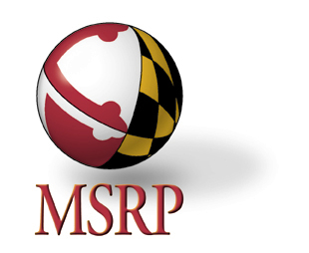

Maryland Teachers and State Employees Supplemental Retirement Plans
William Donald Schaefer Tower • 6 St. Paul Street • Suite 200 • Baltimore, Maryland 21202-1608
Phone: (410) 767-8740 Toll Free: 1 (800) 543-5605 Website: www.MSRP.maryland.gov

