Associate Executive Director
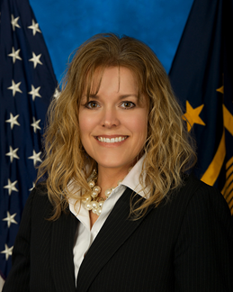
Technology Acquisition Center

Michele R. Foster
In December 2013, Michele R. Foster was appointed as the Associate Executive Director of the Technology Acquisition Center in Eatontown, NJ. In this role, she is directly responsible for the acquisition planning, execution and management of goods and services in support of the Department of Veterans Affairs, Office of Information and Technology.
Ms. Foster began her federal career as an Army Materiel Command Intern Contract Specialist stationed at the US Army’s Communications-Electronics Command (CECOM) located at Fort Monmouth, New Jersey. After graduating from the intern program, she continued her federal service career with CECOM, serving as a journeyman contract specialist, procurement analyst, contracting officer and later, group chief responsible for acquiring major weapon systems, services and supplies in support of the Command, Control, Communications, Computers, Intelligence, Surveillance and Reconnaissance Community. She was responsible for the award and management of such contracts as the Strategic Services Sourcing, Common Hardware Software, Rapid Response, and Warfighter Information Network-Tactical Programs during her time with CECOM.
Ms. Foster received her Bachelor of Arts Degree from Muhlenberg College and a Master of Business Administration Degree from the University of Central Texas. In addition to her B.A. and M.B.A, Ms. Foster has also completed courses toward a Master of Science in Information Technology. She is a graduate of the Federal Executive Institute, the Army Management Staff College and holds a Defense Acquisition Workforce Improvement Act (DAWIA) Level III Certification in Contracting, a DAWIA Level I Certification in Program Management and a Federal Acquisition Certification in Contracting, Level III.
Ms. Foster was nominated for the US Jr. Chamber’s Ten Outstanding Young American’s Award and has received numerous Commander’s notes and coins throughout her career. She is a member of the National Contract Management Association and the Armed Forces Communications and Electronics Association.

