Grave Creek Mound Archaeological Complex
Programs and Events

801 Jefferson Avenue, Moundsville, WV (304) 843-4128
Open 9 am – 5 pm Tue – Sat. Closed Sun and Mon
Outdoor access is weather permitting and closes at 4:30 pm
Fall 2016

All events are open to the public free of charge except as noted

Programs

Saturday, September 10, noon - 4 pm
Fossil Day
Bring your fossils for expert identification by Dr. Ronald Mc Dowell, senior research geologist and head of the Geoscience Section of the West Virginia Geological and Economic Survey (WVGES). Family-oriented activities include cracking open rock matrix to find your own fossil, craft activities, and the film, “Rocks and Rivers: West Virginia’s Geologic Heritage”, produced by the WVGES in cooperation with the National Science Foundation. A new highlight is the exhibit, “Prehistoric West Virginia”, with tours by E. Ray and Mary Ellen Garton of Prehistoric Planet, who are the curators and owners of the exhibit.
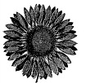
In addition, visit our display at the Elizabethtown Festival which will be held across the street at the old West Virginia Penitentiary 10 am – 6 pm on September 10 and 10 am – 4 pm September 11. The festival features local history, food, crafts, special activities, exhibits, and more.

Saturday, September 24, 9 am – 5 pm
Smithsonian Museum Day Live!
Celebrate the harvest season with our “Garden Checklist” and other seasonal activities.

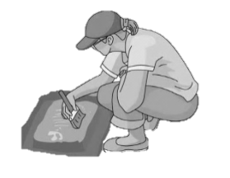
Saturday, October 1, noon - 4 pm
Archaeology Day
Our annual Archaeology Day features special exhibits, demonstrations, and activities for the whole family. These include behind-the-scenes tours of the Archaeological Research Facility, flint knapping demonstrations, atlatl throwing, a museum scavenger hunt, displays and demonstrations by several professional archaeologists, and more.

Saturday, October 15, 1 pm and 3 pm
International Archaeology Day
Celebrate International Archaeology Day with the PBS film, “Secrets of the Dead: Headless Romans” (60 min). This documentary seeks to identify over 45 Roman era skeletons that were discovered in York, England. Placement of the skulls, along with cut marks on the bones, tell a tale of a violent end. New research will be discussed after the film.

Saturday, October 22, 2-3 pm
Historic Ohio Valley Ghost Tales
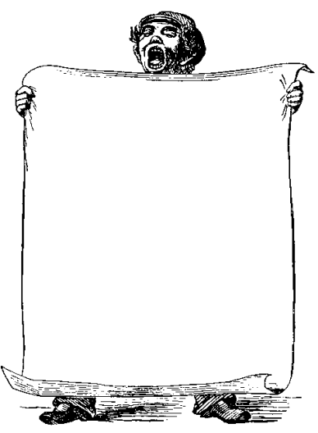
Storyteller Rich Knoblich tells tales of mystery and suspense centered around the lower Wheeling District and into Marshall County. Knoblich has won multiple Liars Contest awards at the Vandalia Festival held each spring in Charleston by the West Virginia Division of Culture and History.

Saturday, November 12, 8:00 am - ?
Annual Meeting of the West Virginia Archeological Society
Featured Artist
of the Month:

September:
Drew Gonchoff

October and November:
To be announced

Each year, archaeologists working throughout the state of West Virginia report their latest findings at the annual meeting of the West Virginia Archeological Society (WVAS). Includes a book signing of “Early Native Americans in West Virginia: the Fort Ancient Culture” by Darla Spencer. Registration begins at 8:00 am and the presentations will continue into the afternoon. Non-members are welcome. Cost is $7 for WVAS members, $10 for non-members, and $5 for students. Pre-registration is recommended but not required – please contact Darla Spencer, WVAS Secretary/Treasurer at 304-561-4753 or dispencer@suddenlink.net .
OVER
At the Discovery Table
Free family crafts available during regular museum hours

Make a Mammoth Puppet - Through Saturday, September 10
Make a mammoth puppet from a paper bag and other odds and ends.
Museum Memory Book - Tuesday, September 13 through Saturday, October 22
Bring home a souvenir booklet you made yourself as a reminder of your museum visit.

Ring-And-Pin Game - Tuesday, October 25 through Saturday, November 12
Make this game of skill using rings made from squash that grew in the museum’s Interpretive Garden.

Holiday Seed Ornaments - Tuesday, November 15 through the 2016-17 holiday season
Seeds from the museum’s Interpretive Garden will be used to create a unique holiday decoration.

2016 Archaeological Lecture and Film Series

Rosser’s Raid on Beverly: One Last Frolic for the Confederacy
7:00 pm, Thursday, September 29
W. Hunter Lesser, Author, Archaeologist, and Interpreter
As ice and snow gripped the Alleghenies in January 1865, Confederate General Tom Rosser launched a raid on the Union depot at Beverly, Randolph County, West Virginia. Surprising the Yankees after a late-night dance, Rosser's raiders plundered the town and carried off twice their number in prisoners. Archaeology aids in revealing this tragicomic tale. Mr. Lesser is the author of Rebels at the Gate: Lee and McClellan on the Front Line of a Nation Divided.
WV Archaeology Month Program: Plantation Archaeology, Industrial Slavery and the Glenwood Project
7:00 pm, Thursday, October 20
Robert Maslowski , Retired Archeologist, U.S. Army Corps of Engineers, Huntington District
Slave-based agriculture and the salt industry were two of the most important economic pursuits in the early history of West Virginia. The treatment of the enslaved workers differed greatly because slaves in the salt trade were leased instead of owned directly. These differences are revealed in excavations at the Jenkins Plantation on the Ohio River, the Reynolds home and slave cabin at the Marmet Lock Replacement project, and the Glenwood Estate in Charleston, WV.

Native American Heritage Month Program: The Trail of Tears Experience of Ohio’s Iroquois
7:00 pm, Thursday, November 17
Christopher B. Chaney, Unit Chief, Criminal Justice Information Law Unit, FBI Office of the General Counsel
Mr. Chaney is a member of the Seneca-Cayuga Nation from Oklahoma who currently resides in West Virginia. In 1832, Seneca and Shawnee tribal members living in Ohio were forcibly removed from their homes and faced deprivation and death on the Trail of Tears. Upon arrival in Indian Territory (now Oklahoma), the tribal members forged a new way of life only to find their dreams shattered by the Civil War. Key to the survival of the Seneca-Cayuga Nation during this tumultuous time was Quashacaugh, also known as Lewis Davis, who is Mr. Chaney’s great-great-grandfather.

Second Saturday Films

Find information on the latest
programs, exhibits, and events,
“Artifact of the Week”,
and more at

www.wvculture.org
www.facebook.com/gravecreekmound
www.twitter.com/gravecreekmound

Saturday, September 10 (playing continuously during Fossil Day)
Rocks and Rivers: West Virginia’s Geologic Heritage (19 min)

Saturday, October 8, 1 & 3 pm
Secrets of the Dead: Vampire Legend (60 min)
The vampire legend is re-examined through clues found in medieval burials. There is a surprising twist – in England.
This film will be repeated on Saturday, October 29, 1 & 3 pm

Saturday, November 12, 1 & 3 pm (90 min)
We Shall Remain: After the Mayflower
See the “First Thanksgiving” through Native American eyes in this episode of American Experience produced by PBS.

