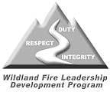
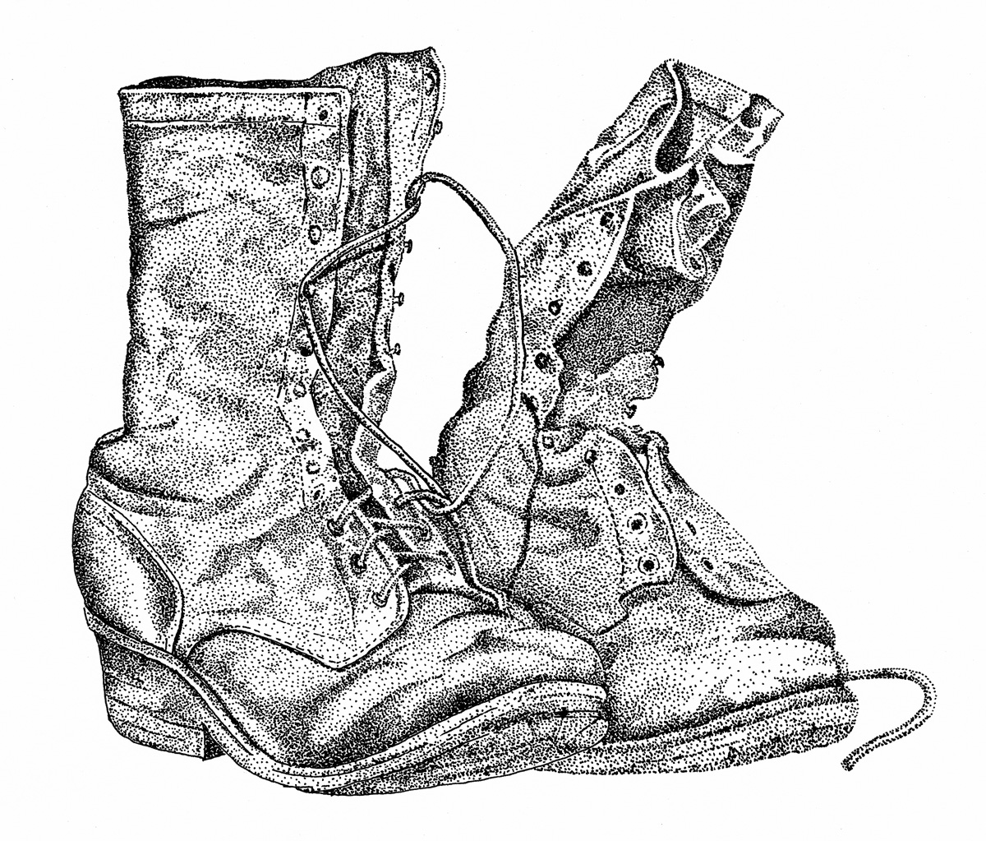
Paul Gleason Lead by Example Award
Lifetime Achievement
Ted Putnam, PhD
April 27, 2005
DUTY… RESPECT… INTEGRITY…
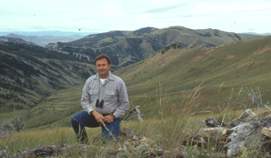
- MENTORING AND TEAMWORK
Developing others for the future
and building the team.
- MOTIVATION AND VISION
Providing Inspired Vision and
Clear Intent
- INITIATIVE AND INNOVATION
Executing outstanding Initiative
and providing Vision

On April 27, 2005, the Wildland Fire Leadership Development Program awarded the first ever Paul Gleason Lead By Example Award – for Lifetime Achievement to Ted Putnam, PhD. It is immensely fitting that the award was presented at the IAWF – International Safety Summit, entitled 10 Years Later. The summit marked the 10th Anniversary of the first ever Human Factor Workshop, initiated in large part by the work and commitment of Ted Putnam following the tragic loss experienced on the South Canyon Fire of 1994 near Glenwood Springs, Colorado.
The dialogue and the events that were initiated at that first Human Factors Workshop in Missoula, Montana changed everything regarding how our leaders viewed the way in which we grow our people and prepare them to lead in difficult and high consequence environments. Indeed, the ideas and the values that were expressed in this pivotal event in our Wildland Fire communities and cultures, initiated the very birth of what would become the Wildland Fire Leadership Development Program itself. How fitting then, that the award for Lifetime Achievement in Leadership by Example, named for another of the icons in our history, Paul Gleason, would be bestowed in a place that spurred the creation of a mindful approach to Human Factors on the fireline and beyond, and to a man that many would consider the father of such ideals in our culture.
The Wildland Fire Leadership Development Program would like to extend its gratitude and appreciation for the courage and the guidance of Dr. Ted Putnam and we honor his steadfast conviction to standby his values and principles that placed the safety and well-being of the firefighter on the ground foremost in our national discussions. We would like to ongratulate Dr. Putnam for his accomplishments and look forward to his continued work to help us grow.
In a separate effort to capture important elements of our history and to honor the exemplary leadership of Dr. Putnam, the Wildland Fire Leadership Development Program conducted an interview regarding his experiences and his thoughts on leadership and human factors studies and practices. Readers are highly encouraged to visit the Wildland Fire Leadership Development Program’s website and the Leaders We Would Like to Meet feature to learn more about the experiences, the contributions and the leadership of Ted Putnam.
http://www.fireleadership.gov/toolbox/leaders_meet/interviews/leaders_TedPutnam.html

