LEADERSHIP IN CINEMA
Band of Brothers - Part Nine: Why We Fight

Submitted by: B. Dempsey–Asst. Captain (C-8)
R. Cota – Captain (C-8)
North Zone Fire Management
Black Hills N.F.
E-mail: bempsey@fs.fed.us
rjcota@fs.fed.us
Phone (605) 642-4622
Audience Rating: R
Released: 2001
Studio: HBO Pictures
Genre: War/Drama
Runtime: 56:00

Materials: VCR or DVD (preferred) television or projection system, Wildland Fire Leadership Values and Principles handouts (single-sided), notepads, writing utensils.

Intent of Leadership in Cinema: The Leadership in Cinema program is intended to provide a selection of films that will support continuing education efforts within the wildland fire service. Films not only entertain but also provide a medium to teach leadership at all levels in the leadership development process—self or team development. The program is tailored after Reel Leadership: Hollywood Takes the Leadership Challenge. Teaching ideas are presented that work with “students of leadership in any setting.” Using the template provided by Graham, Sincoff, Baker, and Ackerman, facilitators can adapt lesson plans to correlate with the Wildland Fire Leadership Values and Principles. Other references are provided which can be used to supplement the authors’ template. (Taken from Leadership in Cinema website)

Lesson Plan Objective: Students will identify Wildland Fire Leadership Values and Principles illustrated within Band of Brothers and discuss leadership lessons learned with group members or mentors.

Basic Plot: (Overall Movie) Band of Brothers. Starting with their rigorous boot camp training in Georgia in 1942, the miniseries recounts the remarkable achievements of this volunteer rifle company, which parachuted into France early on D-Day morning 1944; spearheaded the Market-Garden and Rhine offensives; engaged the Nazis in Bastogne and the Bulge; and captured Hitler’s “impenetrable” Eagle’s Nest at Berchtesgaden in 1945. (Taken from the HBO official website)

This Emmy-winning miniseries etched an unforgettably vivid portrait of WWII, as experienced by an Army unit serving in Europe, which parachuted into Normandy on D-Day and fought for the remainder of the war. Band of Brothers gives the history and tells the story of Easy Company, 506th Regiment of the 101st Airborne Division, US Army. Drawn from the interviews with survivors of Easy Company, as well as soldiers’ journal and letters, Band of Brothers chronicles the experiences of these young men who knew extraordinary bravery and extraordinary fear. (Taken from www.history.com)

Summary for Part Nine: Why We Fight: Easy Company finally enters Germany, to surprisingly little resistance, and has a chance to relax for the first time in a long time. A patrol in a nearby forest discovers an abandoned Nazi concentration camp, still filled with emaciated prisoners. The local citizenry, unbelievably disavowing knowledge of its existence, is made to clean it up, as the news arrives that Hitler is dead. (Taken from http://www.hbo.com/band-of-brothers/episodes/0/09-why-we-fight/synopsis.html)

Cast of Main Characters: (Photographs of main characters at the end of the list)
- Pvt. Webster / David Webster
- Capt. Winters / Richard D. Winters
- Capt. Spiers / Ronald Spiers
- Pvt. O’Keefe / Patrick O’ Keefe
- Lt. Nixon / Lewis Nixon
- Sarg.Randleman/ Bull Randleman
- Col. Sink / Robert Sink

Facilitation Options: Band of Brothers is an excellent leadership film addressing multiple facets of the wildland fire leadership values and principles. Various avenues can be pursued depending upon the facilitator’s intent. At a minimum, students can identify the Wildland Fire Leadership Values and Principles that are illustrated in the film. Students should be less concerned with how many principles they view within the film and more concerned with how the principles they do recognize can be used in their self development as a leader. The film can be viewed in its entirety or by clip selection depending on facilitator intent and time schedules. Another method is to have the students view the film, and then hold the discussion session with the entire group.

Full-film Facilitation Suggestion:
When opting for the full-film method, the facilitator should follow the outline below:
- Facilitator will go over a basic plot of the movie and cover the objective.
- Review the Wildland Fire Leadership Values and Principles with students. (Hand out sheets.)
- Advise students to document instances within the film that illustrate/violate the Wildland Fire Leadership Values and Principles on the handout provided.
- Show students Band of Brothers - Part Nine: Why We Fight
- Break. After showing the movie, provide at least 15 minutes for a break, and also give time for the students to discuss their finding and reflect on how this movie applies to their jobs and private lives.
- Have students discuss their findings and how they will apply leadership lessons learned to their leadership role in wildland fire suppression. The facilitator can reference the specific clips (see specific clip usage section) to encourage further discussion or help clarify points of interest.
- Wrap up the session and encourage students to apply leadership lessons learned in their personal and work lives, as well as take the opportunity to initiate or update their leadership self development plan. Also, consider mentioning to the students about acquiring a mentor and relate this to the self development plan.

Clip Facilitation Suggestion:
When opting for the clip method, the facilitator should follow the outline below:
- Break into smaller groups. (Optional) But consider breaking up into three groups, one for each of the Leadership Values and Principles (example).
- Review the Wildland Fire Leadership Value or Principle(s) targeted for discussion. Hand out the sheets, and briefly go over each one, duty, respect and integrity.
- Facilitator will go over a basic plot of the movie and cover the objective.
- Facilitator will briefly describe the clip and guide the discussion of the clip to the specific principle that is discussed. Make sure to get plenty of feedback from the students before revealing the answer. (Spend approximately 5 minutes per clip).
- Have students discuss their findings and how they will apply leadership lessons learned to their leadership role in wildland fire suppression. The facilitator can reference the specific clips (see clip facilitation section) to encourage further discussion or help clarify points of interest.
- Wrap up the session and encourage students to apply leadership lessons learned in their personal and work lives, as well as take the opportunity to initiate or update their leadership self development plan. Also, consider mentioning to the students about acquiring a mentor and relate this to the self development plan.

Specific Clip Usage for Band of Brothers - Part Nine: Why We Fight:
Facilitator Hint: Ensure familiarity with each individual clip in order to guide the groups.
- The following clips may assist facilitators with leadership discussions. All times are approximate. (Start time/Stop time).

DUTY

Discussion point one (11:00/13:30): Winters tells Nixon he has been demoted, although Nixon at the time is more worried about how to tell the parents their kids have been killed during their initial drop on Normandy. How does this affect Nixon’s attitude and his duty to accomplish the job at hand during this episode?

Discussion point two (37:00/48:00): The American patrol finds the concentration camp in the woods. Discussion point: Make sound and timely decisions.

Discussion point three (47:20/47:40): Col. Sink tells Captain Winters to put the concentration camp detainees back into the camp. How does duty override respect and the integrity in this type of situation?

RESPECT

Discussion point one (22:24/23:06): Private Frank Perconte gives Captain Spiers his lighter to light his cigarette, and Perconte realizes that he might not get the lighter back. How does this affect a supervisor to employee relationship?

Discussion point two (28:30/30:00): After the surrender of the German Army, EZ Company is driving past thousands of German soldiers. Private Webster is yelling at the soldiers in anger. Discuss how this relates to keeping your subordinates informed. Have you ever had to go into a situation without knowing all the information? How did that affect the way you accomplished the mission?

Discussion point three (32:00/33:00): While looking for alcohol, Capt. Nixon walks into a German officer’s house and finds a picture of a German officer. The officer’s wife walks in while Nixon is holding the picture; he drops the picture. Discuss how this clip fits in with the values and principles of respect by setting the example.

Discussion point four (36:00/37:00): EZ Company experiences the horrors of the concentration camp. Discuss how respect and duty fall into play when in a difficult situation.
INTEGRITY

Discussion point one (19:30/20:00): Nixon is developing a drinking problem and breaks into a shop looking for alcohol. Discussion point: Seeking responsibility for your actions.

Discussion point two (29:30/29:40): Local soldiers take three German prisoners to execute them in front of a building while EZ Company passes by in the truck. Discuss how this clip affects O'Keefe, a new addition to EZ Company in the truck, and how the situation reflects the mental, moral and ethical difference between O'Keefe and the “hardened” members of EZ Company. Do you think this effects the way O'Keefe will become part of the team?

Discussion point three (51:00/53:00): The commanding officer invokes Marshall Law, and the town people must help EZ Company clean up the concentration camp. Discuss how EZ Company shows not only integrity, but also respect and duty.

References:
- http://www.hbo.com/band/landing/currahee.html ~ HBO.com’s Band of Brothers website
- http://www.yale.edu/lawweb/avalon/wwii/wwii.htm ~ World War II documents: The Avalon
Project of the Yale Law School
- http://www.archives.gov/digital_classroom/lessons/powers_of_persuasion/powers_of_persuasion.html ~ Powers of Persuasion: Poster Art of World War II – online educational program of the National Archives

Resources - Books:
- Ambrose, Stephen E. Band of Brothers: E Company, 506th Regiment, 101st Airborne from
Normandy to Hitler’s Eagle’s Nest. New York. 1992.
- Kennedy, David. Freedom from Fear: The American People in Depression and War, 1929-1945. 1999.

Hyperlinks have been included to facilitate the use of the Wildland Fire Leadership Development Program Web site. Encourage students of leadership to visit the Web site at:

http://www.fireleadership.gov

BAND OF BROTHERS – PART NINE: WHY WE FIGHT
Facilitator Reference

Below is a short list of examples from the movie that coincide with the Wildland Fire Leadership Values and Principles. Discuss leadership lessons learned from the film with the class and have the class discuss these within their groups. Have the group document film clips illustrating the Wildland Fire Leadership Values and Principles.

Duty
- Be proficient in your job, both technically and as a leader.
- Maintain situational awareness in order to anticipate needed actions.
- Improvise within the commander’s intent to handle a rapidly changing environment.

  - Winters tells Nixon he has been demoted. (How is this portrayed as being proficient at your job? As a leader think, of a situation where it was hard to speak up and say something).
  - The example of Col. Sink telling Captain Winters to put the concentration camp detainees back into the camp. (How does duty override respect and the integrity in this type of situation?)
  - Winters giving a briefing to his men when they first arrive at the concentration camp. (Specifically, how did the briefing appeal to you as a recipient?)

Respect
- Know your subordinates and look out for their well being.
- Put the safety of your subordinates above all other objectives.
- Take care of your subordinates needs.
- Observe human behavior as well as fire behavior.
- Consider team experience, fatigue and physical limitations when accepting assignments.

  - Winters knows all the men under his command by name. (Why is this important?)
  - Nixon informing EZ Company of daily duties that needed to be done. (How does this relate to looking out for your subordinates well being?)
  - Perconte and his response to O’Keefe while working together. (How was this response by Perconte viewed throughout the episode as team building? Was it positive or negative?)

Integrity
- Share the hazards and hardships with your subordinates.
- Actively listen to feedback from subordinates.
- Set the example.
- Don’t show discouragement when facing setbacks.
- Choose the difficult right over the easy wrong.
- Credit subordinates for good performance.

  - Spiers knew his capabilities and those of his men. (By his actions, could you assume that he embodied the “know yourself” principle?)
  - When Nixon breaks into the home looking for alcohol, how do his actions throughout the episode change in regards to his actions? (Why was this response so important?)
  - Winters shares in the hardships of his subordinates. (What sorts of examples can you give of him sharing in the hardships of his subordinates?)

QUESTIONS TO GENERATE FURTHER DISCUSSION
Excerpt from:
“Leaders We Would Like to Meet” Interviews

What makes you want to follow someone?

What kind of leader do you think you are? What do you think others would say?

If you were to pick three of the most important character traits for an effective leader, what would those be?

Are leaders born or made?

Who are some of the individuals that had a significant influence on your life? Currently, who do you think is a role model and why?

If you are not currently in fire, how do you think this movie could be applied to your job?

What are some of the toughest decisions or dilemmas you have faced? What helped to guide you through those situations?

Why do you think people follow you?

How do some of the events in Band of Brothers apply specifically to your job, to your personal life?

Which character in Band of Brothers do you think is most like you?

How do you go about initiating a new idea in order to put it into practice?

Regarding leadership, what quotes come to mind?

  - “Before honor comes humility.” Proverbs

  - “Lead me, follow me, or get out of my way.” General George Patton

  - “Leadership is not only doing the right thing, but it is doing the right thing at the right time.” Life Application Bible

  - “Leaders are not born, they are made. They are made by hard effort, which is a price all of us must pay to achieve any goal that is worthwhile.” Vince Lombardi

  - “Only one man in a thousand is a leader of men, the other 999 follow women.” Groucho Marx
BAND OF BROTHERS – PART NINE: WHY WE FIGHT
Student Handout

Document film clips illustrating the Wildland Fire Leadership Values and Principles and discuss leadership lessons learned from the film with the class.

DUTY

1. Be proficient in your job, both technically and as a leader.
2. Maintain situational awareness in order to anticipate needed actions.
3. Improvise within the commander’s intent to handle a rapidly changing environment.

RESPECT

1. Know your subordinates and look out for their well being.
2. Put the safety of your subordinates above all other objectives.
3. Take care of your subordinates needs.
4. Observe human behavior as well as fire behavior.
5. Consider team experience, fatigue and physical limitations when accepting assignments

INTEGRITY

1. Share the hazards and hardships with your subordinates.
2. Actively listen to feedback from subordinates.
3. Set the example.
4. Don’t show discouragement when facing setbacks.
5. Choose the difficult right over the easy wrong.
6. Credit subordinates for good performance.
Wildland Fire Leadership Values and Principles
Duty | Be proficient in your job, both technically and as a leader.  - Take charge when in charge.  - Adhere to professional standard operating procedures.  - Develop a plan to accomplish given objectives.
Make sound and timely decisions.
- Maintain situation awareness in order to anticipate needed actions.
- Develop contingencies and consider consequences.
- Improvise within the commander’s intent to handle a rapidly changing environment.
Ensure that tasks are understood, supervised and accomplished.
- Issue clear instructions.
- Observe and assess actions in progress without micro-managing.
- Use positive feedback to modify duties, tasks and assignments when appropriate.
Develop your subordinates for the future.
- Clearly state expectations.
- Delegate those tasks that you are not required to do personally.
- Consider individual skill levels and development needs when assigning tasks.
Respect | Know your subordinates and look out for their well being.  - Put the safety of your subordinates above all other objectives.  - Take care of your subordinate’s needs.  - Resolve conflicts between individuals on the team.
Keep your subordinates informed.
- Provide accurate and timely briefings.
- Give the reason (intent) for assignments and tasks.
- Make yourself available to answer questions at appropriate times.
Build the team.
- Conduct frequent debriefings with the team to identify lessons learned.
- Recognize individual and team accomplishments and reward them appropriately.
- Apply disciplinary measures equally.
Employ your subordinates in accordance with their capabilities.
- Observe human behavior as well as fire behavior.
- Provide early warning to subordinates of tasks they will be responsible for.
- Consider team experience, fatigue and physical limitations when accepting assignments.
Integrity | Know yourself and seek improvement.  - Know the strengths/weaknesses in your character and skill level.  - Ask questions of peers and superiors.  - Actively listen to feedback from subordinates.
Seek responsibility and accept responsibility for your actions.
- Accept full responsibility for and correct poor team performance.
- Credit subordinates for good performance.
- Keep your superiors informed of your actions.
Set the example.
- Share the hazards and hardships with your subordinates.
- Don’t show discouragement when facing setbacks.
- Choose the difficult right over the easy wrong.

Leadership Self-Development Plan
For Wildland Firefighters. . . a Lifetime of Learning
(See http://www.fireleadership.gov/toolbox/documents/self_develop.html for level-specific self-development plans)

Next level of leadership: Leader of People | Leader of Leaders | Leader of Organizations

Time horizon for plan:
Directed Reading and Other Self-Study (www.fireleadership.gov):

Training (Next wildland fire L- and S-courses):

Details (Temporary assignments with new or increased responsibility):

Mentor (Identifying and asking a role model to provide guidance):

Outside Activities (Little league coach, Big Brothers/Big Sisters program, etc.):

Employee: Date:

Supervisor: Date:

Main Character List for
Band of Brothers - Part Nine: Why We Fight
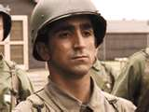  Private Perconte: Has a Pivotal role in this episode, not only finding the concentration camp, but also working with a new member of EZ Company. | 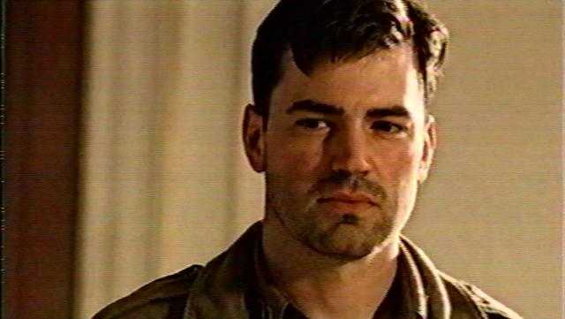  Captain Nixon: Has a Major role in this episode, not only with moral ethics, but also personal issues as well.
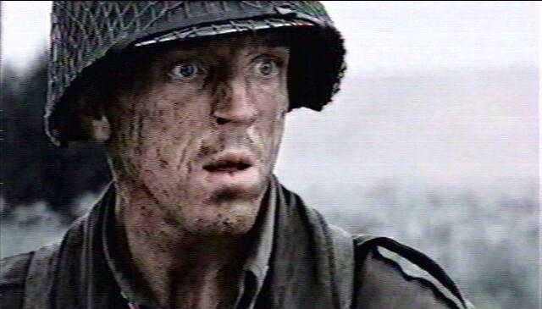  Captain Winters: Continues to provide solid leadership and support to EZ company with timely words and actions. | 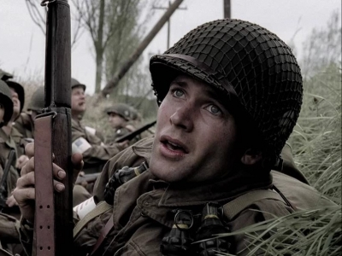  Private Webster: Has a minor role in this episode. His role shows us the anger and misunderstanding one might have in difficult situations.
Captain Spiers: Plays a minor role with Pvt. Perconte in this episode. | 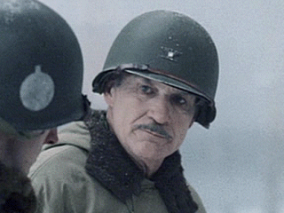  Col.Sink: Has a minor role in this episode.
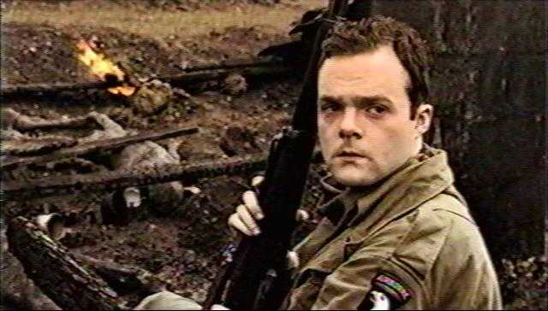  Private O’Keefe: As a new member of EZ Company, Pvt. O’Keefe looks forward to finding action until he sees the horrors of the Nazi concentration camp. | 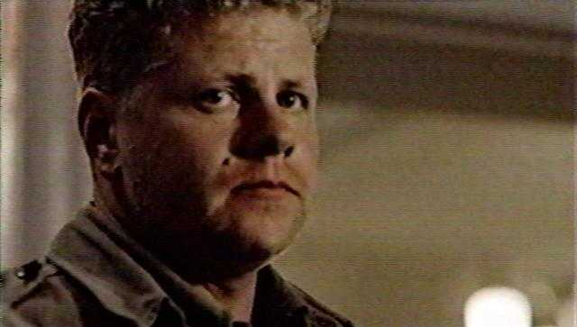  Sergeant Randleman: Bull has a limited role in this episode.

